# New Type of Password Visualiser

## Department of Computing

Georgi Damyanov

University of Kent

28 April 2019

## **Abstract**

This report documents the creation of my password universe visualisation (PU) which is modelled on a web application. This PU is used to visualise a given password database as the “universe” and the entries as “stars”. The user is treated as the centre of this universe by choosing a keyword to compare with the database. Database doesn’t necessarily need to be with passwords, it can be any combinations of strings such as an English dictionary. It’s mostly aimed at password researchers and cyber security experts allowing them to see patterns thus helping them to gain further understanding of how passwords are related to one another. It can allow users to compare the same password with different databases and gain results of how users come up with their passwords. In this report we learn what the real issue is with users and their passwords, how does it affect us and how a lot of people are deceived and uninformed that their passwords are not secure. This PU proposes a solution into gaining more data in the field of passwords that can be used in order to improve password policies. Afterwards there is a description on how the code works with code examples, what decisions I made to create it and what is the potential future work.

## **Acknowledgements**

I would like to thank my supervisor Dr Shujun Li for supporting me throughout this project by giving variety of ideas and compromising on certain aspects of the code due to my unexperienced with certain technologies.



**Contents**

**1.** **Introduction** 3

**2.** **Related Work** 4

2.1 Password Security 5

2.2 Password Visualisers 6

**3.** **Design & Implementation** 6

3.1 Levenshtein Distance 7

3.2 Colour Switch 7

3.3 Information Table 8

3.4 Sorting algorithm 9

**4.** **Results** 10

**5.** **Known issues** 13

5.1 Password case 13

5.2 Initial scaling 13

5.3 Outlier distribution 13

5.4 “Call stack” 13

**6.** **Conclusion** 14

6.1 Final Result 14

6.2 Future Work 14

**6.2.1** **General Improvements** 14

*6.2.1.1* *Zoom feature* 14

*6.2.1.2* *Selecting data points* 14

**6.2.2** **Adding Features** 15

*6.2.2.1* *Uploading databases online* 15

*6.2.2.2* *Multiple results and Overlap* 15

*6.2.2.3* *Frequency addition* 15

**References**…………………………………………………………………………………………………………………………………….16

## **Introduction**

There are billions of accounts hacked every year, unhashed data being spread around the internet that can be gathered if you know where to look. For example, recently there was a leak of millions of emails and passwords stolen and a lot have been unhashed and are spreading around [1], making hacking users easier using standard password cracking techniques such as dictionary attack, brute force attack and rainbow table attack. However, there is also a problem that with such huge database of real unhashed user passwords, that many other can be potentially at risk because they have had a similar or the same password as the one that got hacked causing a leak of for example 10 million, possibly affect a much larger population. Alternatively, even if the user is aware that his password has been hacked, he will use a simple pattern to change it. This project aims at using any password database to visualise potential patterns people have whilst creating their passwords which can be used to potentially strengthen the requirements for passwords on websites. For example, research such as this can be used to improve something most websites have, proactive password checkers (PPC) about which we will talk more in Section 2. How does one decide what rules to add to their requirements for these password meters? Different password meters perform differently [2] [3] [4]. There was a research made in 2010 stating that our current password creation policies are still vulnerable to online attacks [5] and this issue still persists as more and more users are keeping the same passwords, using the same patterns of creation without much knowledge of them being hacked and vulnerable, and as I mentioned even if they know, most will result to a simple pattern fix. When starting this project, I had multiple scenarios presented to me for data visualisation that I can approach such as;

1. Heat maps – generalised heat map giving the frequency of each character at each position and each password is a segmented line on the heat map.

2. Human related passwords – passwords related to geo-locations, related to a person’s name, animals, plants and even religion, languages and wars.

These two are just some of the many ideas I was given by my supervisor but I chose to go along with the “Passwords in a universe” where each star is a password and the user keyword is in the middle of this universe.

The reason behind me choosing this idea is because personally I could already see the possibilities of how much this can benefit the most out of the patterns I wanted to achieve, I could visualise what I want to build and how I would like to make it work, and the issue was how I would achieve that. Nonetheless I believe I made the correct choice and I hope this tool can help improve and break patterns that current users have with regards to their passwords. I will talk more about different visualisers and my reasons for choosing this later in this paper.

I believe that with the power of visualisation, it can be much easier to actually see patterns and collect data otherwise left unseen. The use of visualisation techniques have been used for a very long time from maps to visualise one’s location to graphs, to visualise one’s data. In a short Q&A video, Simon Samuel, Head of Customer Value Modelling for a large bank in the UK, he answers the question “How important is data visualisation” by saying:

“Visualisation is fundamental and it will be increased with its usage going forward. The executive of the bank where I work currently demands more visualisation tools to help them support their insight and analysis and also to accelerate their understanding”.

Visualisation can identify areas needing for additional attention much easier and simpler for the human brain to see and identify. Any visualisation tools that can help understand data and make important decisions on how to detect patterns and do our best to correct them can be useful [6], tools like those can show us also different scenarios to solidify the best potential choice.

## **Related Work**

Simple text passwords are the most used form of identification and grant permissions. Even though there are many other ways of identifying yourself such as face recognitions, thumb prints, key cards etc. most places still use the standard password. By default if something is used the most, it should be the most secure in terms of identification but in regards to password cracking, its currently a big issue because of how users create their passwords and once leaked somehow, even if warned, they persist to make simple changes instead of making a serious change in their passwords. There are password checkers to try and make users to think of newer passwords and it has worked in the past but the issue persists that users keep creating similar passwords.

Most users when creating a password have fallen into some known patterns that they use assuring themselves that their passwords are secure. An issue comes from the overly rated password meters which allure users to believe that since it satisfies the meter, their password is surely secure and hard to crack [7] [8].

For all examples below in this section, I will be using a standard initial password: “password”.

There are a few common patterns that people use to make their password more secure. For example, capitalising the first or last letters of their password. One of the most common password meter requirements is to have one upper and one lowercase letter. Users are so used to their current passwords that they choose to adapt their current password by just capitalising a letter in their password that would be easy for them to remember but yet satisfy the password meter. For example, turning “password” into “Password”, “passworD” or “PassworD”.

Furthermore, there is also the “1” or any short combination of following numbers at the end of the password. Again this comes from the standard requirement of password meters requiring at least one number into your passwords giving users a false sense of security to users thinking their password is securely protected [9].

For example, changing the initial password to “password1”, “password12” or “password123321”

Finally, there is another common pattern people use as an alternate or with the one stated above which is replacing letters with similar looking numbers such as (t → 7, s→ 5, I → 1, o→ 0). For example, “password” would turn into “pa55w0rd” or “pas5w0rd”.

Combining all of these tricks the standard “password” would turn into potentially something like “Pas5w0rd123” which from the normal users perspective makes him believe that this change of his password. Password meters are evolving but they are doing small changes which just pushes users into more patterns which eventually makes no difference of their password being cracked.

These are some of the most known patterns and if one of a user’s old passwords has ever been compromised by a leak or any other way, there is a high chance the person trying to crack you will try to follow all of these pattern combinations. These examples show how users are overly relying on just satisfying a password requirement leading to ideal security for their passwords. This calls for a drastic improvement on password meters, something has to change and the ideal way is to notice as many patterns as we can that users are creating and proposing solutions to these patterns so we can tighten securities.

### Password Security

When it comes to password security a big issue is that the majority of users don’t actually study about password patterns or any password safety, they highly rely on the providers (where they register at) to deal with all the security and they commonly create passwords that are easy for them to remember not thinking that the issue is that many other people will think of the same thing. There has been research on semantic patterns showing that like to use dates or certain words for their password that they find close to them and easy to remember. The research is based on the Rockyou table and they found out that about 4% of the passwords are date related only and can be cracked easily with a dictionary attack with about 200,000 entries in a table [10]. This proves to be clear issue and requires the improvement of password policies and give appropriate guidelines for users to improve their passwords. Through the years one common method of trying to tackle this issue is using a proactive password checker (PPC) which is the tool websites commonly used to measure user password strengths and make sure the user password retains certain conditions and those conditions are based on the password meter function (PMF) embedded in the PPC.

People have tried improving PMF’s which are generally based on certain password composition policies which restricts the usage of simple weak passwords that are highly vulnerable to statistical attacks and add more criteria to them or changing the algorithms to portray how strong the password actually is [11] but even with all these changes, users just start creating more patterns that do not get addressed which causes PPC to display password as strong giving a false sense of security to the user.

For example:

Let’s take a short combination of my date of birth (DoB) and name and satisfy a PPC, something that is close to me and easy to remember. I will be using “9970707gG!1” Where “997” comes from the year I was born 1997, the “0707” are day and month, “gG” comes from my first name letter, and just capitalising it to make the password requirements happy, and “1!” which is just the first number on my keyboard to again just satisfy the password checker. Now this might seem secure but in reality, this is just a mix of simple patterns to update my original password “9970707” which is what I had at the beginning and it’s fairly easy to guess if the attacker has any knowledge of me but the PPC won’t know that and it would say it’s a good password, even without any knowledge, there is a high chance such password is on some rainbow table which are simply put tables with common leaked passwords.

PPC’s do work and still work in general about most things but something has to be done and improved in the field for users to create more secure passwords. PPC’s mostly act as a password guideline at the moment.

Alternatives are password managers (PM) those are tools that allow users to store all their password behind a single master password and most will auto-fill the passwords for the users on the web. The tools will generate a good password for the user and store it in a hashed format. PM’s do partially work but not many people know about them and if they do, they still don’t bother using them. Good examples of PM’s right now are 1Password and LastPass which are very reliable and simple to use and setup for all desktops and mobile devices.

### Password Visualisers

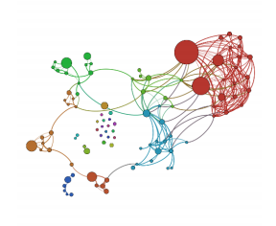There are graphical examples of password visualisation where researchers have tried to showcase password evolution again by using Levenshtein distance by using the top leaked passwords of websites. Their results show that passwords also like humans have aspects of communities and social networks by being linked in some way to one another. It helps them visualise chains forming from different password distances and the evolution of one password to another. Using these visualisation techniques they have tried to also determine how users create their passwords and analyse their password patterns to improve current password policies and give appropriate guidelines for the aiding of more secure passwords [12]. This visualisation method excels at portraying the evolution of passwords, it tries to portray there is no entropy between passwords created from different individuals by showing how all passwords get connected and how communities and clusters are formed. This visualisation techniques achieves similar results to what my visualisation method is portraying, the usage of colours and circles, clusters and sizes based frequencies are all parts of future work possibilities or alternatives of this project.

*Figure 1 Graph visualisation of top leaked passwords by* [12]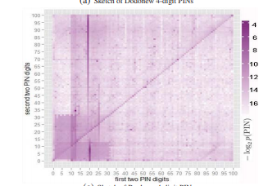  
  
Alternative visualisation technique is also heatmaps which are great to visualise 2d and 3d data by having X-axis, Y-axis and colour were used in a paper to visualise user PIN’s by plotting on the X-axis the first two digits of their pin and on the Y-axis the last two digits of the PIN [13]. Those heatmaps allowed to easily view patterns on which two digits are used the most at start and end by forming lines on each axis. An example for spotting patterns on heatmaps would be where the line is much sharper it would represent a frequent usage, if two lines are crossing each other, the cross-section of those lines would be a commonly used full pin number. This visualisation techniques suits this scenario because its much easier to split a 4-PIN in two half’s and analyse them, the data will not be skewed and the possibilities of a longer passwords are none, you will always be able to split in two and they will truly be similar, otherwise if you had longer passwords they can be uneven and harder to split, the data on each half will not be as similar to one another and its harder to create patterns.

*Figure 2 Heat map visualisation of PINs by* [13]

## **Design & Implementation**

Unlike password checkers which use some algorithm to detect the total amount of symbols, numbers or other variables within the password to determine its strength, this PU uses an edit distance using Levenshtein distance formula to determine the total number of mutations a password needs to take to go from A to B or in this case, from the keyword a user typed to every database entry. All databases that I have used are online and are unhashed plain text leaked passwords that were made available for research purposes.

### Levenshtein Distance

How Levenshtein distance (LD) works is it looks at the first string, in our case it’s the keyword a user has entered. Let’s say its “password”. Then it looks at the string inside our database, “p@sword”. As visualisation look at Figure 3 below, the algorithm would look at each character in in both strings and one by one determine if the character matches, if it has to be changed to match or a new character has to be added instead. In our case, the edit distance in this example would be 2 because to get from the initial password, to the second password, you need to:

1. Change the ‘a’ character to ‘@’.
2. Remove the second ‘s’ character.

|  |  |  |  |  |  |  |  |
| --- | --- | --- | --- | --- | --- | --- | --- |
| p | a | s | s | w | o | r | d |
| p | @ | s |  | w | o | r | d |

*Figure 3: Displaying how Levenshtein distance works*

The benefits of using Levenshtein distance is that it completely bypasses most the tricks users use as password patterns and it’s much easier to analyse their password. How LD it works is that it looks at all changes that need be done to get from one password to another so if your password is “password” and you change to for example “[p@ssword](mailto:p@ssword)” or “p4ssword” since both “@” and “4” are known replacements for “a”, a PPC it would determine them in different strength since it would believe that having “@” instead of “4” or a would be better, alternatively if you already have a symbol but no number, it would think having “4” better than “@” but in reality, it’s a single character change to your password.

In the PU, LD is used for the radius for each password, and the angle is found by the alphabetical sorting. For my LD I tested multiple frameworks and codes, I tested npm frameworks from NodeJS, I also tested a few fully JavaScript implementations. I did basic benchmarks to determine speeds and I found out that the differences are minimal but yet the JavaScript implementations I currently keep has a slightly higher speed and allows me to keep my entire code client side.

### Colour Switch

I wanted to have some sort of colour representation to showcase the distance for two simple purposes

* + - 1. I wanted to get quicker visual understanding around what edit distance the diagram is showing
      2. It can create much prettier patterns and it’s easier to visualise and understand using colour cues.

If we look at Figure 4 we can see the code for the colour switches. I’ve split it between 6 radius sections from 0 – 50 and a default case which is pure lemon green to represent it’s a safe password with a long edit distance from the typed centre, the rest of the cases have a default starting hex from black to red to green and each distance will portray a different colour because I am taking the value “stripSingleDigit” which is the full digit value of the edit distance. The reason I need to strip it is because we can get an example digit of 13.2123523 and we only care about the full first number. This function returns the final value and it’s used in the main function where I am creating each dot separately for the fill section.

For example, when I test “9970707gG!1”, the password we used in earlier examples Figure 5, it can clearly be seen that the password in reality, is very similar to other passwords. A lot of the colour is red, distance is between 5 and 10 inside that section. The purpose of this is to show that there are not so many changes to do from a password to reach to another user’s password. Even though a user’s password might not be in danger. Other passwords which were leaked can be in close range to the password entered.

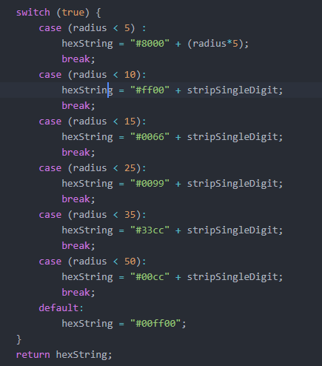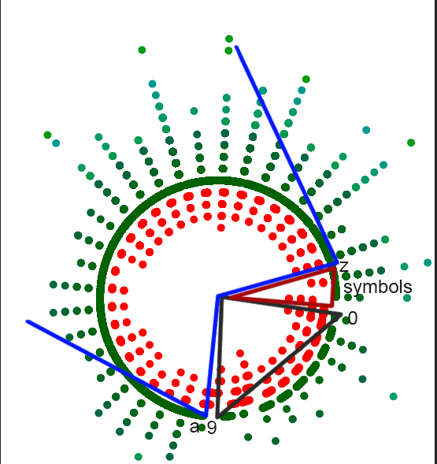

*Figure 4: Switch code for colour fills on circles Figure 5: Diagram of “9970707gG!1” password*

In Figure 5 I have added the blue, red and black lines representing the alphabetical ordering from 0-9, a-z and symbols sections for better understanding of how my alphabetical ordering works.

### Information Table

The visualisation PU creates allows the user to click on an area and see what the passwords are in a radius. There are no passwords directly under each other, but there are a lot of passwords in a very small area with minimal difference between each other for the X and Y co-ordinates, so if a user wants to see what's in a certain area of dots, he can click on them, and on the side there will be an information bar that can be toggled on or off. If you look at Figure 6 you can see a result of a radius when the keyword “password” is entered.

*Figure 6: Information box of passwords*

This information shows leaks of passwords all spelling “password” in a different variation by using some of the patterns we mentioned above in Section 2. Even without using the information box we can determine by just the visualisation that there is some pattern in an area, comparing it to the rest of the visualisation it stands out and the human brain is highly likely to notice that much easier in this visualisation than just looking at the passwords as a plaintext.

The way this function works is it allows for a user to click anywhere on the screen, if he clicks on a dot, it calls a function which creates an array of all dots in the area of size determined inside the code and appends the information I have decided to display inside the information box table which currently is “Distance” and “Unhashed Password”, alternatively if there were results previously already displayed, they will be removed and then the new ones will be appended.

To aid for the understanding of what data is actually being portrayed, I have made it so that the area of dots that being selected are all coloured in dark blue as shown in Figure 7.

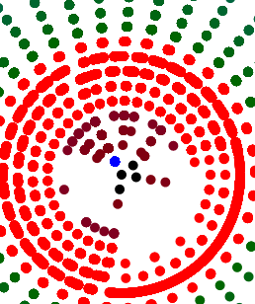

*Figure 7: Highlighted section for the keyword “password” displayed on Figure 6*

### Sorting algorithm

Currently the sorting algorithm is alphabetical. There were alternatives that I could have used such as plotting by frequency in a single circle but for my databases I have chosen to have no frequencies so that choice is mute. Another example was sorting passwords by similarities, if you have a password “ab”, passwords around it will “abc”, “a”, “aba”, etc. anything that is similar forming a huge chain of passwords forming a huge circle. This will have much greater benefits in following how passwords are evolving, referring back to graphical example at Section 2.2, creating such sorting algorithm would potentially mimic similar effects allowing us to see clusters of passwords forming visible patterns, alternatively it would take much longer to understand and code.

The way the current visualisation gets plotted is by me calculating the edit distance explained in Section 3.1, then I decide how many sectors my universe will have. I have a-z, 0-9 and symbols will be treated as 1. This makes total of 37 sectors. I create an array of 37 arrays. Each array inside my main array represent a sector of a circle. Then I iterate through the entire database and take the 1st character of each entry in my database, look it up on the ascii table and determine in which array I will push it into based on that. Once I have determined the array, I will put it inside. Once all entries in the database are placed inside the appropriate sectors, I sort each sector alphabetically using the JavaScript sort function. Now I have all my sectors with all my passwords sorted alphabetically, I now need to get their X and Y co-ordinates. I iterate through my array of sectors and each entry in every sector, I then calculate the X and Y by first finding out what the angle of the password will be. Once I have my radius and my angle, I can use Sin and Cos rules to determine what the X and Y co-ordinates will be. Once you get the X and Y co-ordinates I use the d3js JavaScript framework to plot the data on the webpage inside an SVG container (the PU) and creating each data point as a circle object (the stars in my PU).  
This data can then be used in away way desired but can also be downloaded since I have provided a download feature which would take the entire SVG data and save it on your computer in an SVG format which it can then be used to store the image and represent it using another application or collect different specific data points that could be used for analytical reasons.

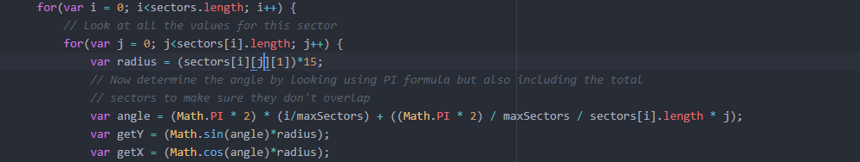

*Figure 8: Code for the co-ordinates generation*

The reason for the *15 in the radius is a naïve attempt to scale the initial displayed graph. This value is not used anywhere else and does not affect the correctness of position on the graph but there are potential issues with doing it this way in which I will talk in a later section about all the issues in the code and how can they be fixed.

## **Results**

I will use this section to showcase data with different passwords to show clear difference of weak versus strong, show potential patterns and what kind of details can researchers analyse. I will be using three different databases. The 1st database I will be using is from Hotmail and it contains 8930 passwords, 2nd database is from MySpace and it contains 37144 passwords and finally I’m using the phpbb password which has nearly 185,000 passwords. I need to note, all these passwords are available to use online for educational purposes. These passwords were leaked or stolen from sites.

I will write a keyword on each database to see if we can see any patterns between these databases. The keywords I will be using are examples of some of the most known passwords in cracked databases. [14]

**Example 1:**

“123456789” a very simple pattern of sequential numbers.

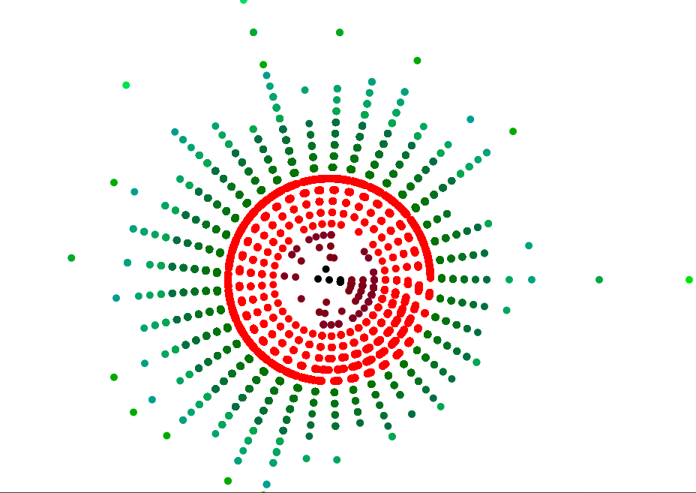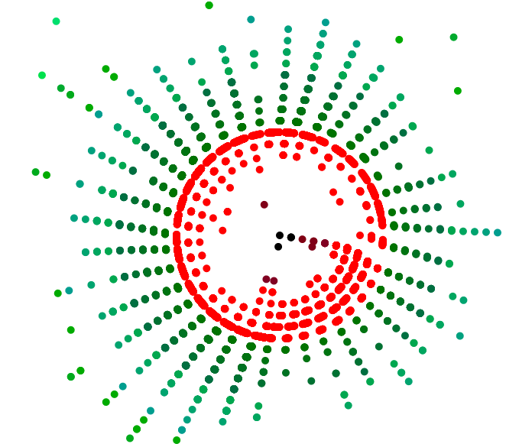 a) phpbb b) hotmail

*Figure 9.1: Patterns of two databases with the keyword “123456789”*

If we can shortly refer back to Figure 5 to check how the alphabetical pattern looks like, we can notice that there is a clear line forming around A-Z potentially hitting some of the symbols suggesting that potentially there are a lot of passwords which start with letters but end in numbers. There seems to be another pattern in both images as well, you can see that within the numbers location, it nearly forms a triangle because of the small amount of empty space. This pattern is a lot more noticeable in the hotmail database, if you look closer you can see that the colours are purple, this is due to the colour settings seen in Figure 4 suggesting it’s around the 0-5 area. If both pattern are downloaded and overlapped you can get a result showcasing how both databases with completely different sizes can form similar patterns showing how users follow their own set of composition policies.

Using this visualisation we can clearly see that there are patterns formed but if we want to analyse it any further, one can start using the Information table I have added to start looking at what these passwords actually are, how are they created and why do they appear where they are which can reveal to common password patterns and help improve PMF’s to prevent from users creating such passwords or at least try and give additional guidance as to why such password patterns are not ideal.

**Example 2**

“password” a very common password usually used as a placeholder password

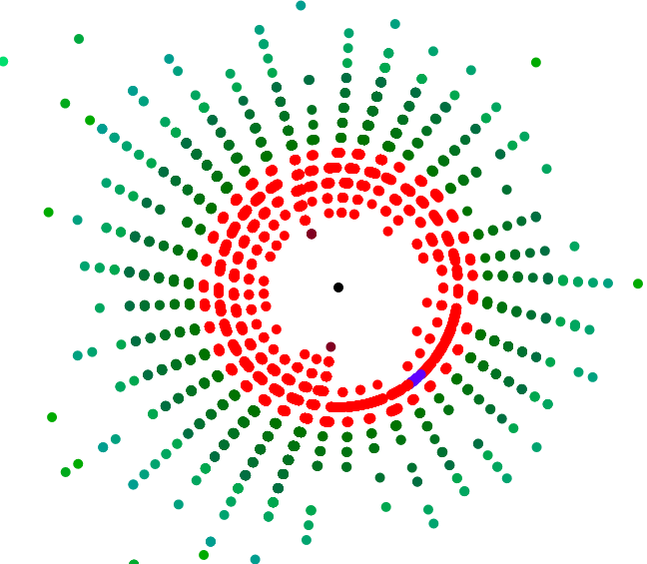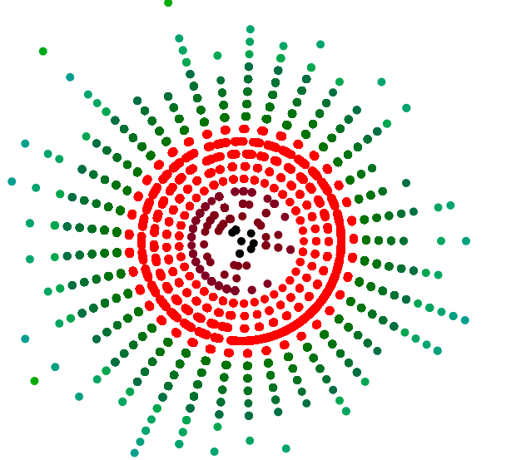

a) phpbb b) hotmail

*Figure 9.2 Patterns of the databases with the keyword “password”*

With this example I am trying to showcase the exact opposite from typing a statistically known sequence of numbers, to a statically known sequence of characters which represents the exact opposite pattern of how users create a lot more similar passwords starting with numbers and potentially finishing with letters.

Alternative pattern that is visible a lot more on phpbb than hotmail since the database is much larger is that around the middle, there is an extreme amount of similar passwords that have been cracked, its nearly covering the entire area which means that a lot more users have had this password or very similar ones leaked than the previous example.

**Example 3**

“7E0@67au1h21G*vR$Bdp0” is a password generated from a password manager “LastPass”

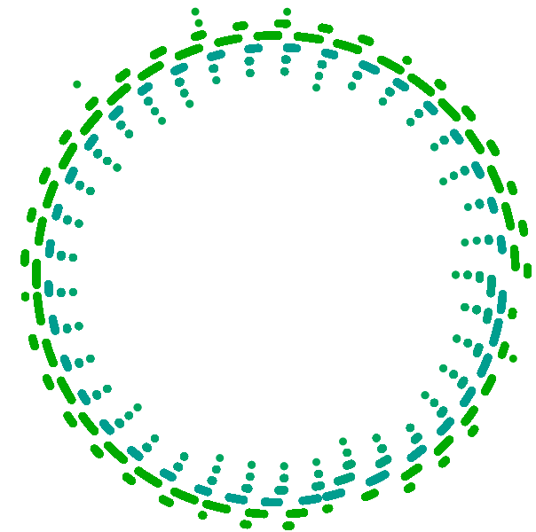

a) phpbb b) hotmail

*Figure 9.3 Patterns of the databases with the keyword “7E0@67au1h21G*vR$Bdp0”*

This example is a clear showcase of a much more secure password, the patterns look absolutely different, you can easily spot that nothing is nearby, the middle is an empty void and showcases a password entropy, and all the passwords are far away forming a nicely patterned circle. We can actually predict that this will happen because the password is absolutely random, it has no similar relations to any passwords. These two results are about 90% similar due to this reason and if we use more databases of leaked passwords, we would get similar results. There is a huge disadvantage of using a password as this, and that is that no normal person would easily remember this, this password has to be written somewhere and that's the advantages of owning a password manager.

Now we can compare Example 1 and Example 2 Figure 9.1 a. and Figure 9.2 a. because they are the same database but different passwords. This shows us that in this database, both of the passwords are very common, the middle section is nearly full for both and the patterns on both are actually very similar because both seem to have the same a-z pattern appearing on the visualisation. The absolute middle section on both has exact matches and around the passwords is full with similar entries. Comparing Figure 9.1 b. and Figure 9.2 b. we can see that unlike phpbb, hotmail patterns on both passwords appear different from 0-9 and a-z but in the absolute centre there are exact matches still. We can also notice that for “password” a term defined as one of the most commonly used passwords [14] has an exact match but no extreme similar entries around it unlike our password for Figure 9.1.

If we had additional time, we could have also compared the passwords inside each circle for different database. For example, we could check how many passwords match exactly in all of sector ‘a’ (passwords that start with the letter ‘a’) or how many passwords in total are with edit distance 4, we could then combine and check how many passwords with edit distance 4 that are in sector ‘a’ match exactly. Furthermore, from some research I found that there is potential to use fractal dimension to help understand the clusters created on the sides, gain more information about whats happening and split them appropriately [15]

All of these examples show that different passwords, can create different patterns and these patterns can showcase variety of things such as how secure a password is by looking at any nearby stars in the PU of each keyword or alternatively common password patterns user create for themselves by trying to create an easily memorable password for much easier access. No matter what the pattern showcases, it can be used to create better password policies for PPC’s or alternatively they could be used for better feedback support to the user if they use some sort of a PPC in the future which can tell them stuff such as “we have detected a common policy users used”, currently we don’t have enough data to provide such suggestions as definitive but this application can help contribute to analysing multiple passwords and collecting such data.

## **Known issues**

Whilst reading this paper there is a possibilities that issues might have been noticed and there are a few issues that I would like to address and how they could be fixed.

### Password case

Starting with a very important issue is that all passwords are actually being changed to full lowercase. This is a problem because currently uppercase and lowercase passwords are treated exactly the same and for this research purposes, we should treat them differently. The reason this was done at start is so that it’s easier to put them into categories, where I mention on section 3.4 where I create the sectors, for the ascii table to make it simpler I made all characters into lowercase, this can easily be fixed if the line where the characters are being turned to lowercase is removed and adapt the total size of the total sectors from 37 to 63 so we can add space for the 26 uppercase characters. We will also need to change how lowercase and uppercase are now ordered, we will want aA bB cC etc. so we will need to play around a bit with the maths to order them. Alternatively, it will be much easier to have for example A-Z a-z or vice versa since it will be a bit simpler to implement.

### Initial scaling

As mentioned and showed at Figure 8, the initial scaling at the moment is *15 and it works in my examples but if someone decides to test a database resulting to very large edit distance results, it will make it absolutely huge and hard to read because the patterns will be very distanced out. I had a solution on this to get the smallest radius distance or the largest radius distance in the array and then decide what you would want the min-max to be and set all passwords by the amount you set the first password chosen. So for example if the smallest password is of radius 5, and you want the minimum to be 15, add 10 to the password and to all other passwords to scale them to reach a minimum, you can do the same with maximum, to get the largest value and scale it down to the largest radius decided on.

Alternatively, d3js provides a scaling algorithm that can be used instead by giving an array of values that you want it to be scaled at and use those values for scaling.

### Outlier distribution

Currently, the way the view gets centred is by getting the largest and smallest X and Y co-ordinates and altering the padding using JavaScript CSS. I couldn’t figure out a way how to keep the circles inside a div box any other way so they kept escaping the container I have added them into and when they keep resizing any other way I tried doing this has failed. This issue is caused due to large outliers in the database, only a single entry needs to be either too large or too small and it can get hugely skewed and left with a lot of empty space. Typical method of solving this is by adding logarithmic function around the radius before it being used for X and Y axis.

### “Call stack”

The browser is saying that I am getting a “Call stack” issue which means that my function is getting stuck in a recursive function and eventually brakes. The issue here seems to be that when I load a huge chunk of database, my code tries to run it all at once and exceeds its memory. I tried to fix it by using NodeJS and I found a solution by using NodeJS blobs and file reader but I couldn’t implement it due to HTML issues. I then proceeded with my research and found that there is a way to do it using PHP as backend but my entire code at the moment is client side with no server side at all so implementing it would have to take a long time. What has to be done is so that the code is read pieces by pieces (blobs) which will be processed and once a single blob is processed and rendered, then a new one would come. I would give size for each blob so it never halts and gets memory errors.

## **Conclusion**

In this section I would to talk about how this project can be taken further, what some of the limitations were and my personal reflection on how I found the project, how it affected me and what I learned.

### Final Result

Finally, after all the research and hard work for this project, I have an application allowing for researchers, security experts, potentially artists to create and analyse patterns visualised on a web page. Currently, the project can visualise a decent size of data, it works with around 100,000 passwords fairly well, it allows for basic features as we have mentioned in this paper such as SVG download, zooming features and information by radius. I have chosen alphabetical sorting for two main reasons. It achieves everything that I required for the visualisation to display and even though it doesn’t’ display in the best way of the choices I spoke about in Section 2.2, it’s much simpler to implement considering the time I had and the research I had to do to understand this project. I believe this project can help in the field of password security, it can be used as a useful tool for the advancement of password research but at the same time it has the potential to be something much greater that I will discuss in my next section for future work.

### Future Work

I took this project and created the basis of other projects which can be potentially way more useful and with time, this project can become an amazing tool but there are certain things that have to be made.

#### **General Improvements**

I want to go over a few general improvements that can definitely improve the current code as it is, make it easier to use and more user friendly. After those improvements, I will be talking about how the code can be adapted to visualise more patterns.

##### *Zoom feature*

The zoom feature at the moment its very basic, all it does is that it scales all X and Y co-ordinates by 1.5 depending if you click zoom in, it multiplies and if you zoom out, it divides. What I would envision ideally be for the user to be able to select an area with the mouse, take that area and zoom only that area by keeping the rest normal zoom. Maybe it could create a new div at the same location the area is but make that div cover the original by allowing the user to zoom in or out depending on how they wish it to be.

Another alternative of the zoom is to create a dropdown scrollbar, that scrollbar can be scrolled up or down and create an ajax zooming potentially where it doesn’t require the user to wait for all points to be re-rendered with the new parameters. To achieve this I believe the d3js scaling could work, but I have not tested it.

##### *Selecting data points*

I showed how one can use the information box to gain data about the databases and try and reveal potential patterns in Section 4 but the issue is that you can only select a certain area as briefly explained in Section 5.4 on how it works, I think it would be better if a user can potentially either:

* + - 1. Select multiple dots, as many as he wants and then click a button to gather all the data from the dots selected and display them, this way a user can select multiple dots from different areas and contrast pattern information much easier.
      2. The same alternative as the zoom feature in 6.1.1 where a user can select an area of different dots and once released and selected the area, all dots inside will display their data.

#### **Adding Features**

Now I want to talk about future works with new features that can improve the overall usage of the application by the user. These are features that can potentially improve user experience or completely change the patterns a user is looking at with the databases.

##### *Uploading databases online*

If this application is to be made public for users to use all over the world, we would need to allow the users to upload their own databases using the online application instead of having to download the code onto their computers. Furthermore, possibly allow different patterns of databases to be uploaded, currently the database is a .js file with a function name and parsed through the html for the d3js file can read the data using basic JavaScript and users might not understand this, so allowing .json , .sql or other file extensions.

##### *Multiple results and Overlap*

Ideally a user would be able to choose multiple words, possibly from multiple databases allowing to store multiple results on the same session and overlapping them. If they can overlap, they will also need the ability to change the colours manually from the online application on each graph, furthermore they should be able to for example keep or remove the entries of both databases from the results that exactly overlap or are within a very close proximity from one another. This way you can for example see the same patterns appearing in different databases or look at the variety of passwords from both databases that can result to such edit distance and allow for a bigger pool of data to be analysed and help determine patterns people use.

##### *Frequency addition*

I would like to potentially start using databases with password frequencies, databases where repetitions of passwords are not removed, but I would also like there to be some use of these databases instead of just clustering extra data that’s unused. One way that frequency data can be used for visualisation is by counting the frequencies on each password and increasing the sizes of the stars in the PU.

**References**

|  |  |
| --- | --- |
| [1] | T. Hunt, “The 773 Million Record "Collection #1" Data Breach,” 17 January 2019. [Online]. Available: https://www.troyhunt.com/the-773-million-record-collection-1-data-reach/. |
| [2] | S. Egelman, A. Sotirakopoulos, I. Muslukhov, K. Beznosov and C. Herley, “Does My Password Go up to Eleven?,” 2 May 2013. [Online]. Available: http://delivery.acm.org.chain.kent.ac.uk/10.1145/2490000/2481329/p2379-egelman.pdf?ip=129.12.11.80&id=2481329&acc=ACTIVE%20SERVICE&key=BF07A2EE685417C5%2E465674151BD0BA75%2E4D4702B0C3E38B35%2E4D4702B0C3E38B35&__acm__=1552856965_fd3233b0869e0192d20f302f14c. [Accessed 17 March 2019]. |
| [3] | B. Ur, P. G. Kelley, S. Komanduri, J. Lee, M. Maass, M. L. Mazurek, T. Passaro, R. Shay, T. Vidas, L. Bauer, N. Christin and L. Faith Cranor, “How Does Your Password Measure Up?,” 2012. [Online]. Available: https://www.usenix.org/system/files/conference/usenixsecurity12/sec12-final209.pdf. [Accessed 10 March 2019]. |
| [4] | S. Li, N. Aljaffan and H. Yuan, “PSV (Password Security Visualizer): From Password Checking to User Education,” 13 May 2017. [Online]. Available: https://link.springer.com/chapter/10.1007%2F978-3-319-58460-7_13. [Accessed 23 March 2019]. |
| [5] | M. Weir, S. Aggarwal, M. Collins and H. Stern, “Testing metrics for password creation policies by attacking large sets of revealed passwords,” 4 October 2010. [Online]. Available: https://dl-acm-org.chain.kent.ac.uk/citation.cfm?id=1866327. [Accessed 17 March 2019]. |
| [6] | M. Daradkeh, C. Churcher and A. McKinnon, “Supporting informed decision-making under uncertainty and risk through interactive visualisation,” 1 February 2013. [Online]. Available: https://dl-acm-org.chain.kent.ac.uk/citation.cfm?id=2525496. [Accessed 20 March 2019]. |
| [7] | T. Emin, “Cracking More Password Hashes With Patterns,” August 2015. [Online]. Available: https://www.researchgate.net/publication/276113338_Cracking_More_Password_Hashes_With_Patterns. [Accessed 20 March 2019]. |
| [8] | “What 10 million passwords reveal about the people who choose them,” [Online]. Available: https://wpengine.com/unmasked/. [Accessed 20 March 2019]. |
| [9] | D. Wheeler, “zxcvbn: realistic password strength estimation,” Dropbox, 10 April 2012. [Online]. Available: https://blogs.dropbox.com/tech/2012/04/zxcvbn-realistic-password-strength-estimation/. [Accessed 27 March 2019]. |
| [10] | R. Veras, J. Thorpe and C. Collins, “Visualizing semantics in passwords: the role of dates,” 15 October 2012. [Online]. Available: https://dl-acm-org.chain.kent.ac.uk/citation.cfm?id=2379702. [Accessed 27 March 2019]. |
| [11] | H. Tupsamudre, V. Banahatti and S. Lodha, “POSTER: Improved Markov Strength Meters for Passwords,” 24 October 2016. [Online]. Available: https://dl-acm-org.chain.kent.ac.uk/citation.cfm?id=2989058. [Accessed 20 March 2019]. |
| [12] | G. Xiujia, C. Haibo, L. Xuqin, X. Xiangyu and C. Zhong, “The Scale-free Network of Passwords : Visualization and Estimation of Empirical Passwords,” 25 November 2015. [Online]. Available: https://arxiv.org/abs/1511.08324. [Accessed 27 March 2019]. |
| [13] | D. Wang, Q. Gu, X. Huang and P. Wang, “Understanding Human-Chosen PINs: Characteristics, Distribution and Security,” 2 April 2017. [Online]. Available: https://dl-acm-org.chain.kent.ac.uk/citation.cfm?id=3053031. [Accessed 28 March 2019]. |
| [14] | M. Burnett, “10,000 Top Passwords,” 20 June 2011. [Online]. Available: https://xato.net/10-000-top-passwords-6d6380716fe0. [Accessed 27 March 2019]. |
| [15] | A. Gionis, A. Hinneburg, S. Papadimitriou and P. Tsaparas, “Dimension induced clustering,” 24 August 2005. [Online]. Available: https://dl-acm-org.chain.kent.ac.uk/citation.cfm?id=1081880. [Accessed 28 March 2019]. |